# **Read Me**

The ‘Persona App’ contains many individual functions such as:

1. ‘Location Geocoding’: This uses Google Maps. The user can search for any location, with the location names typed in the ‘Search’ field. The function is such that, just typing ‘Mission Coll’, it will understand to locate ‘Mission College’ in Santa Clara. This implements the concept of Geocoding.
2. ‘Search’: This takes the user to Google Search so that he/she can look for anything on the internet.
3. ‘Alarm Clock’: This is a custom alarm clock created, where the user can set the alarm clock for any time, and it will give a notification message ‘Time to wake up’ in the mobile phone’s lock screen.
4. ‘Fall Detector’: This will detect a person if he/she falls down and will either call the person whose mobile number is set in the app or message that person if it detects the user fell down.
5. ‘Sleep Aid’: It will give an alert along with vibration to remind the user to sleep whenever it detects a movement while the person is sleeping. This has been created as a sleep aid to help the user to sleep.
6. The ‘Persona’ App created looks like the below snapshot on opening it.

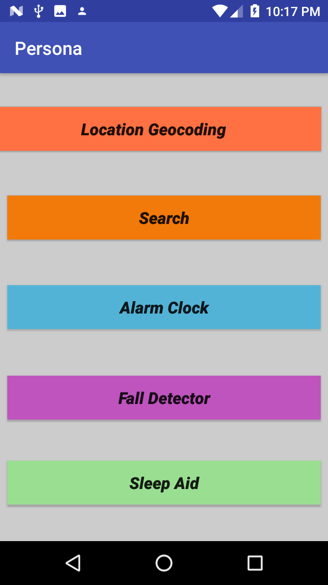

1. On clicking the ‘Location Geocoding’ button from Persona App, the following screen opens. Here, we want to locate ‘San Jose State University’, hence just typing ‘san jose state’ will help to locate the place.

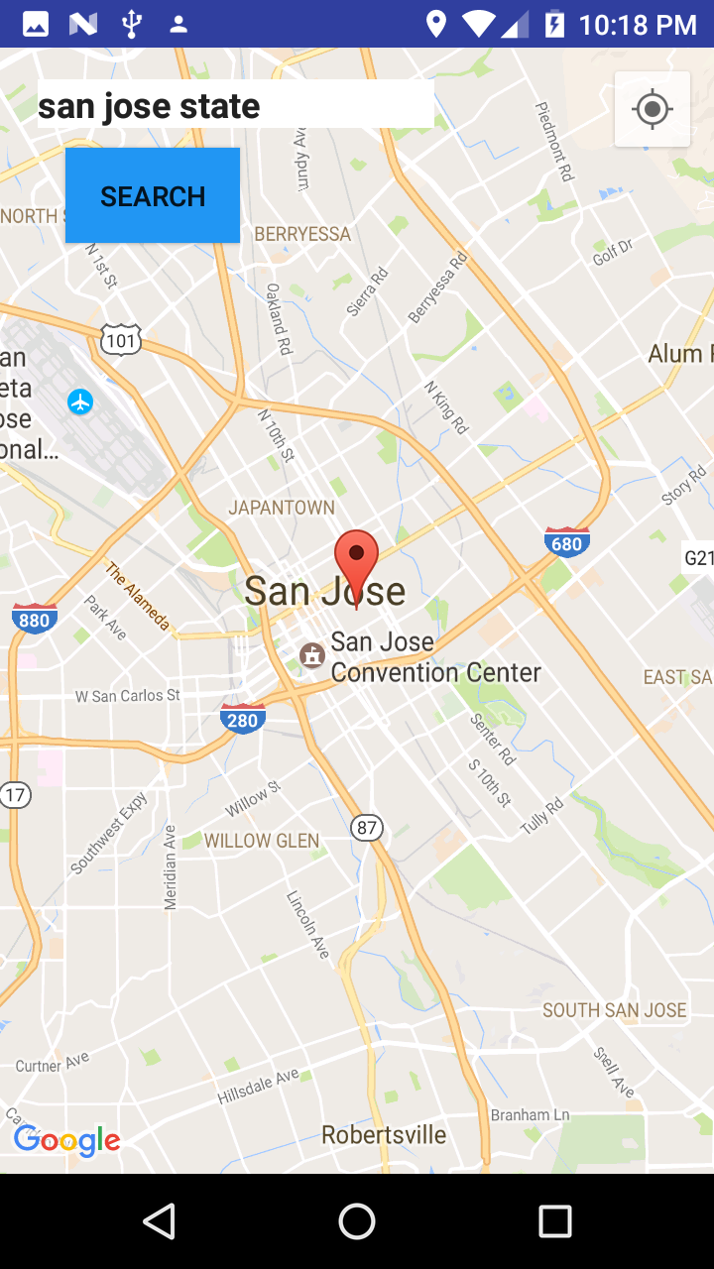

1. Now we want to search for ‘Mission College’, so just typing ‘mission coll’, would locate the place.

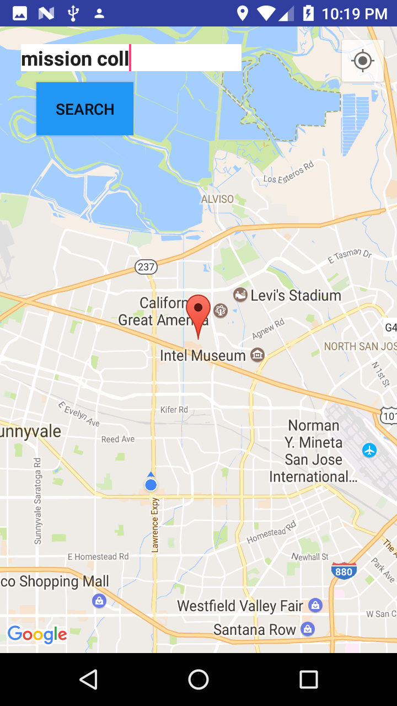

1. The app will mark the places searched for as the below snapshots.

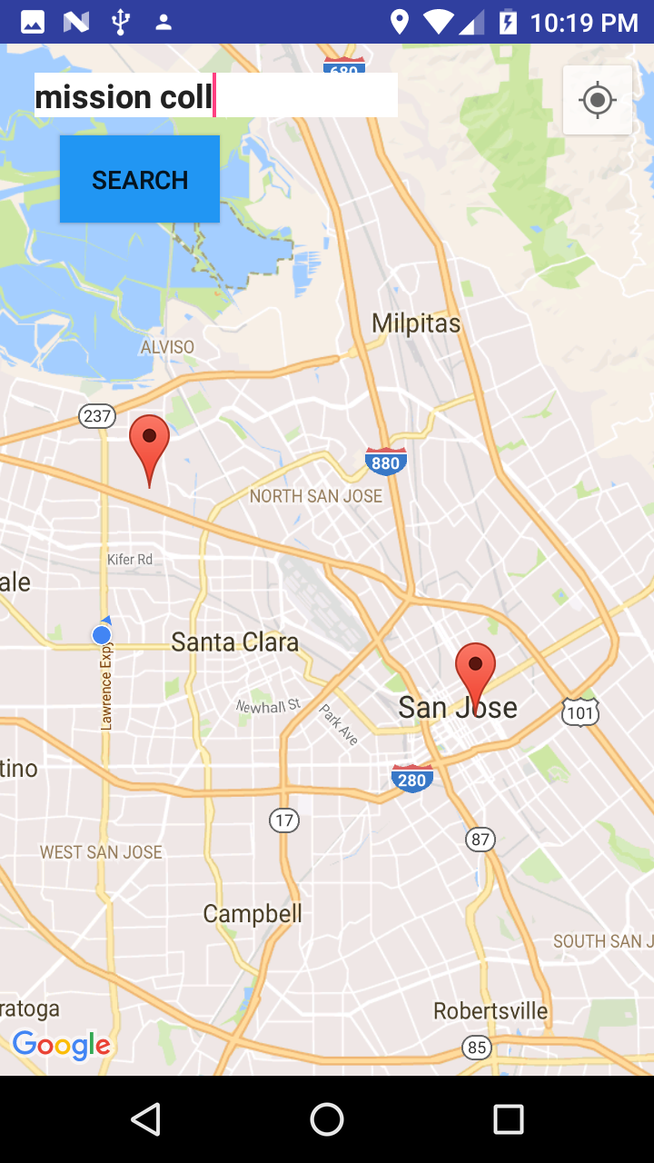

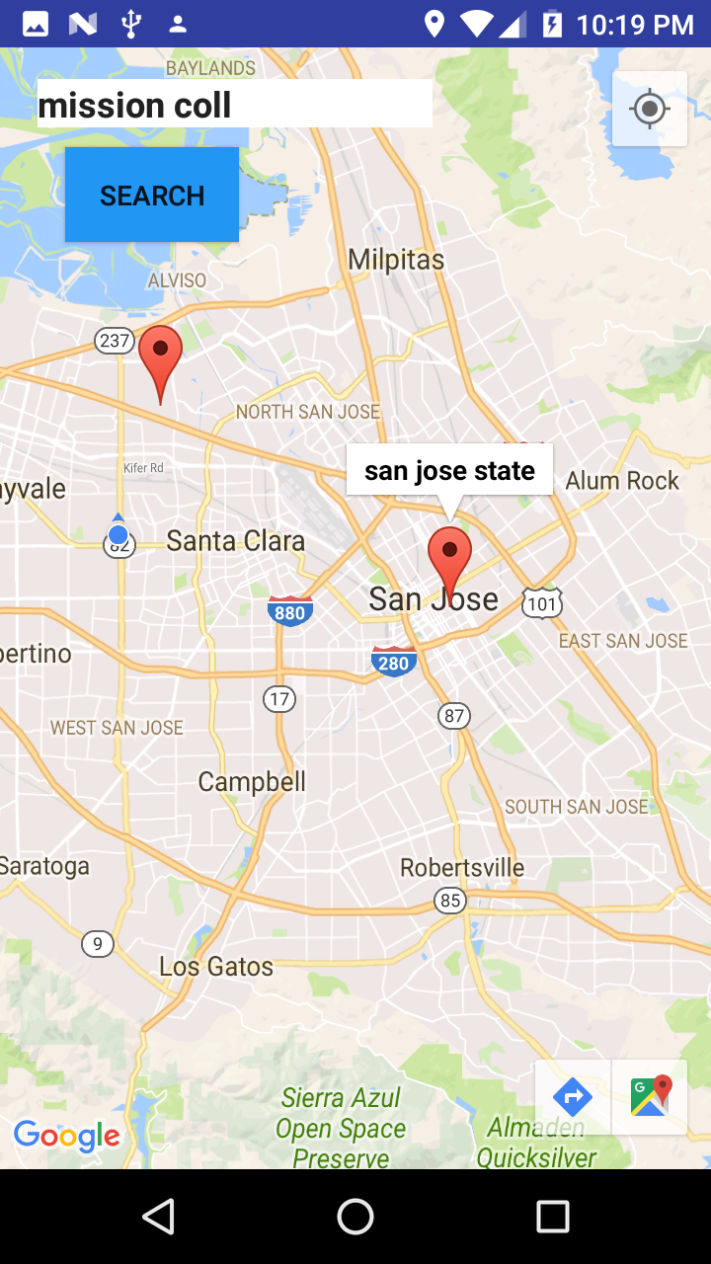

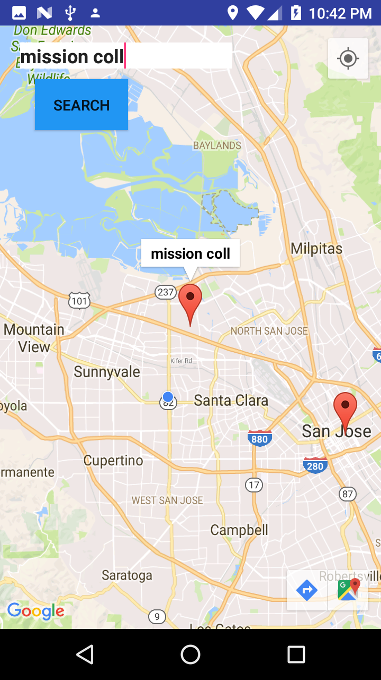

1. On clicking ‘Search’ button from Persona app, it takes user to Google search where the user can look for anything he/she wants to.

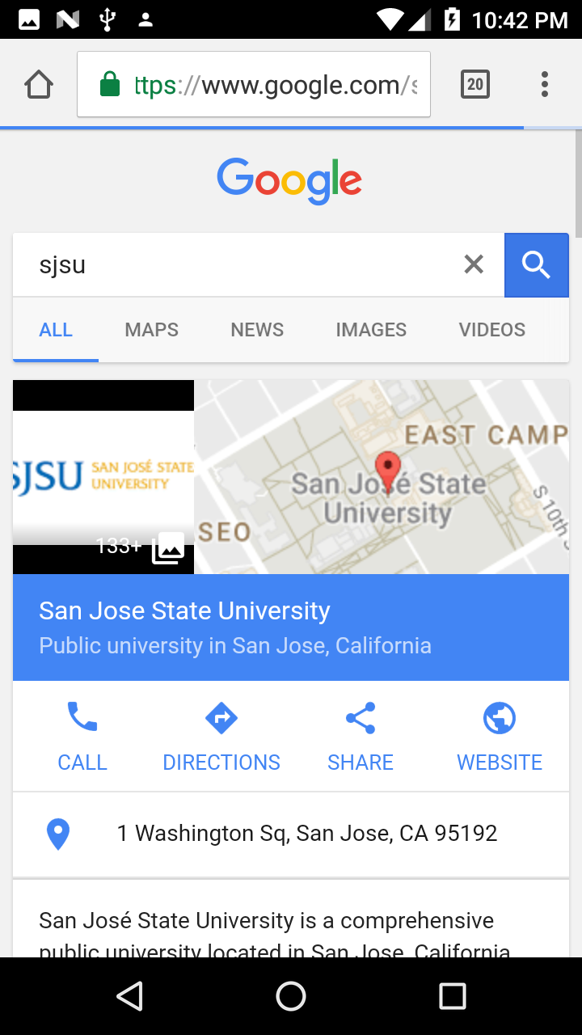

1. On clicking ‘Alarm Clock’ from the Persona app, the user can access a custom alarm clock which he can use to set an alarm for waking up. It gives a notification message ‘Time to wake up’ in the lock screen of the mobile phone.

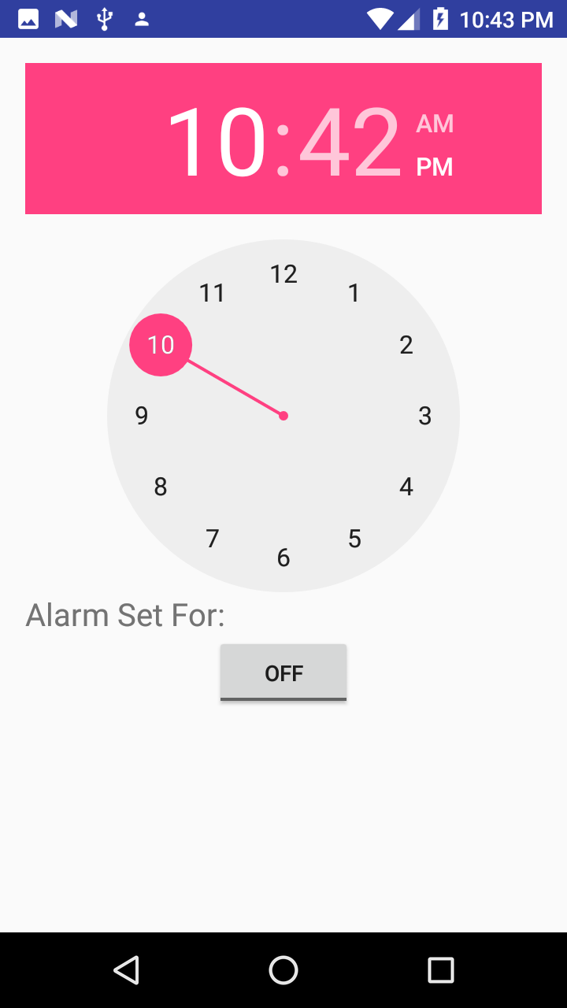

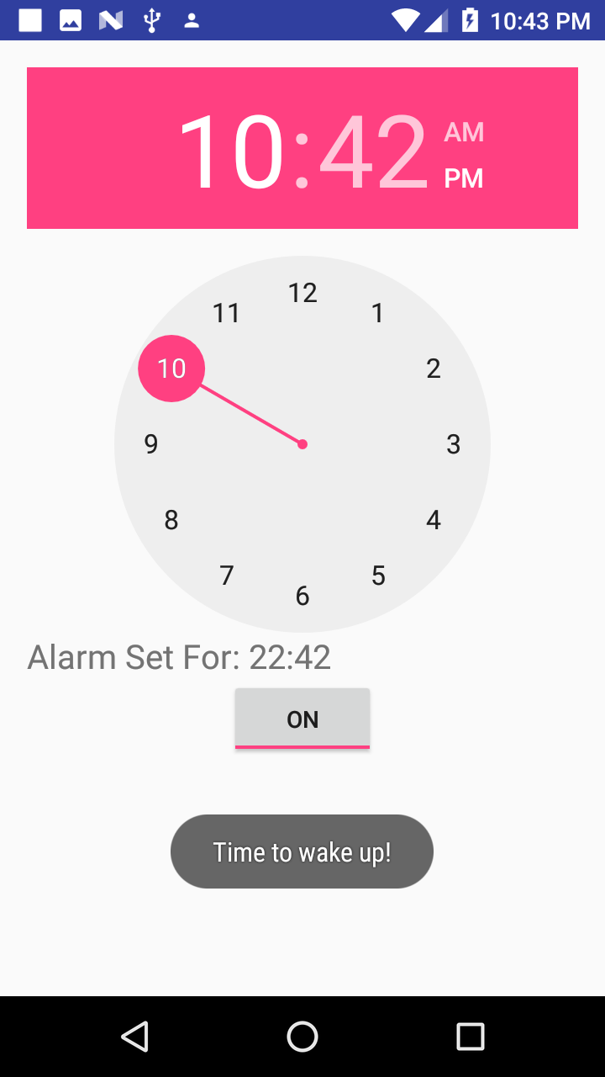

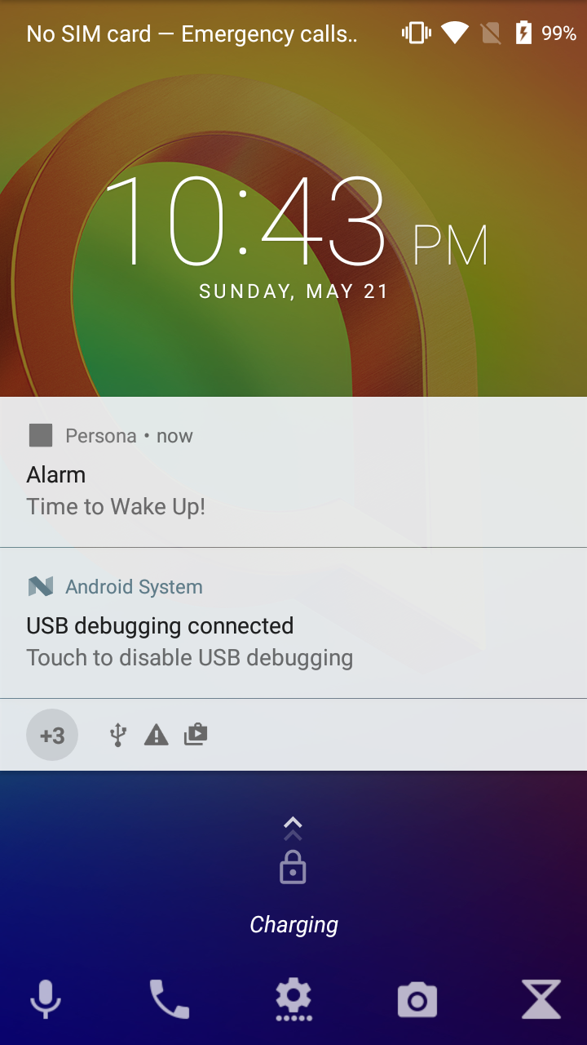

1. On clicking ‘Fall Detector’ button from the Persona app, the user is taken to the below screen. He can set an emergency contact number as below from the Settings function.

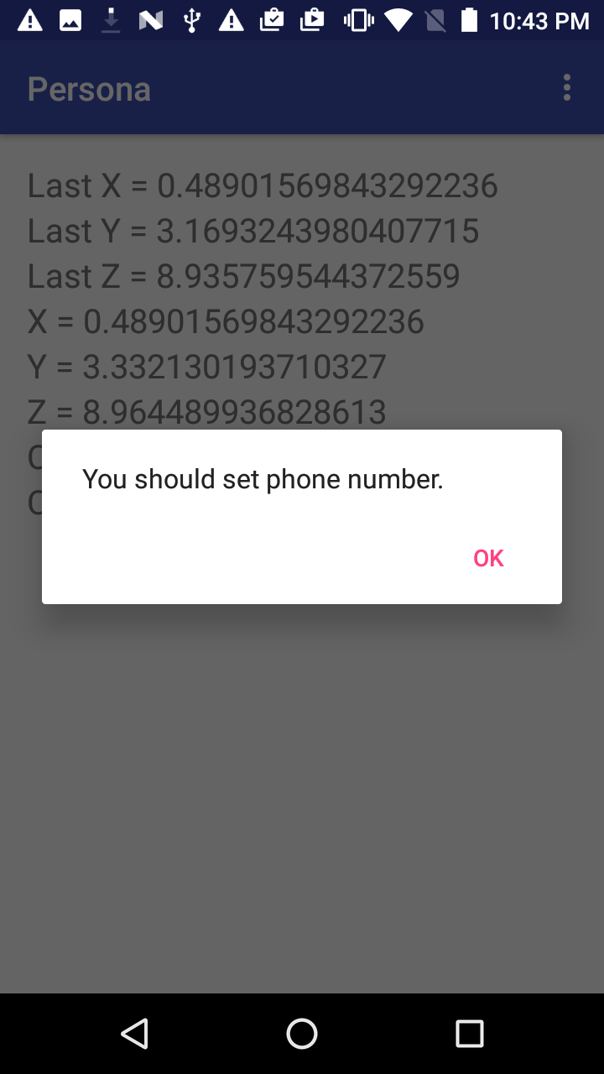

1. The below screen is shown after clicking on ‘OK’ from above screen. Default option here for the notification method is set as ‘SMS’.

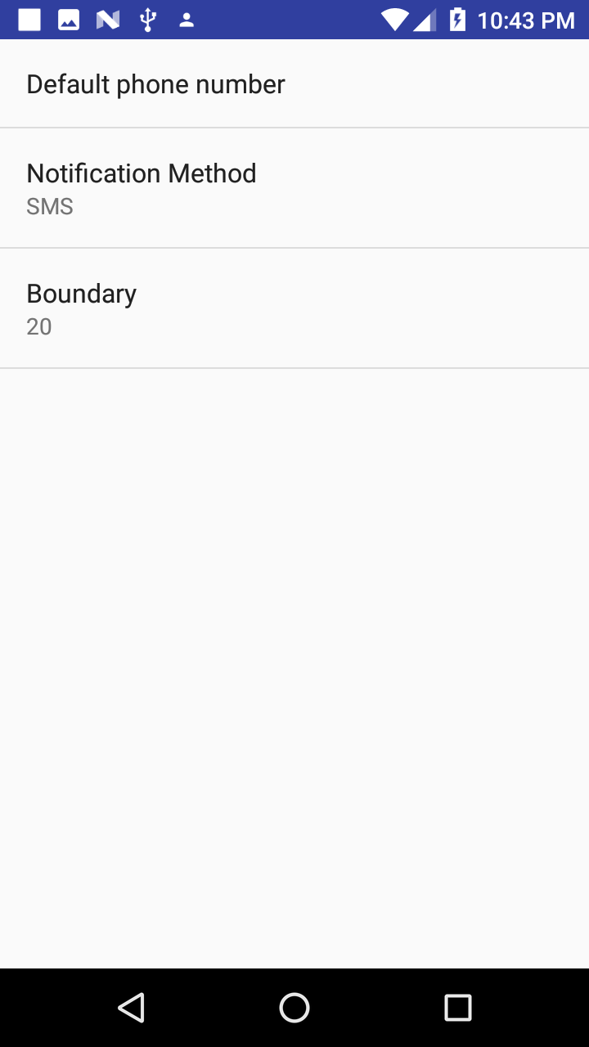

1. After the mobile number is saved, the below screen is shown.

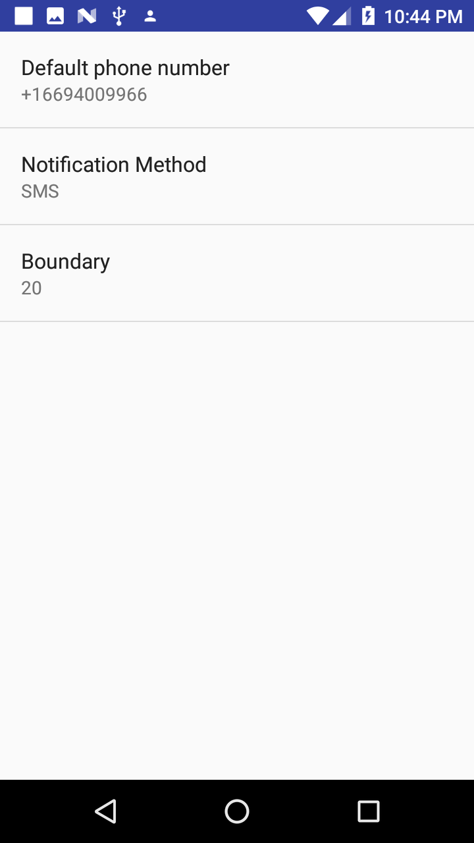

1. As soon as a fall is detected, an SMS is sent to the emergency contact number as shown below.

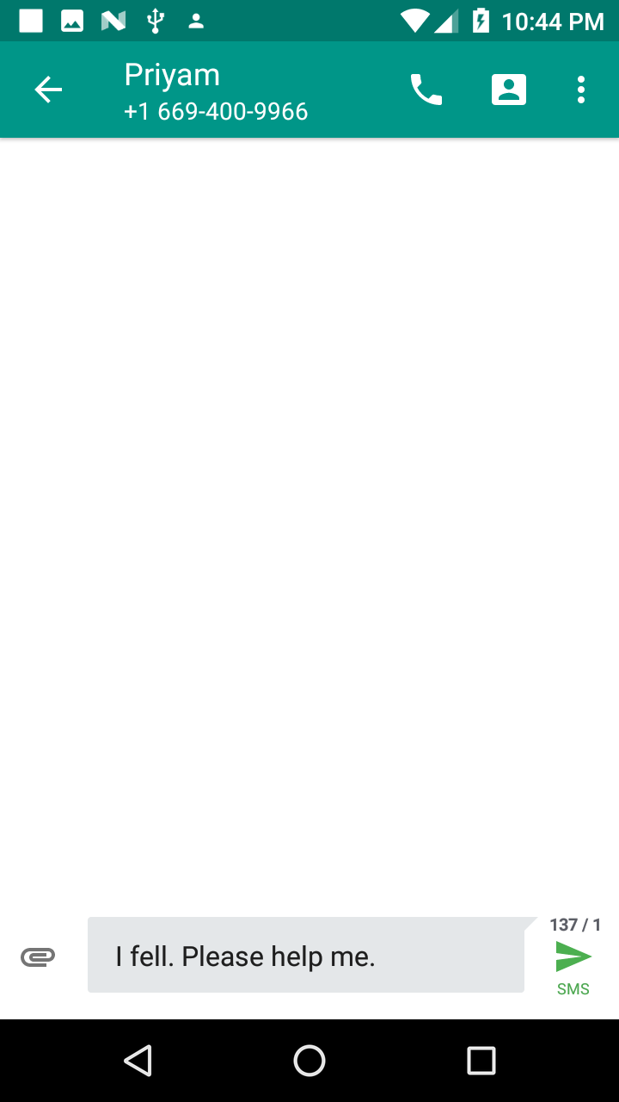

1. The user can set the notification method as ‘Phone’, which will call the person whose mobile number is set as emergency contact.

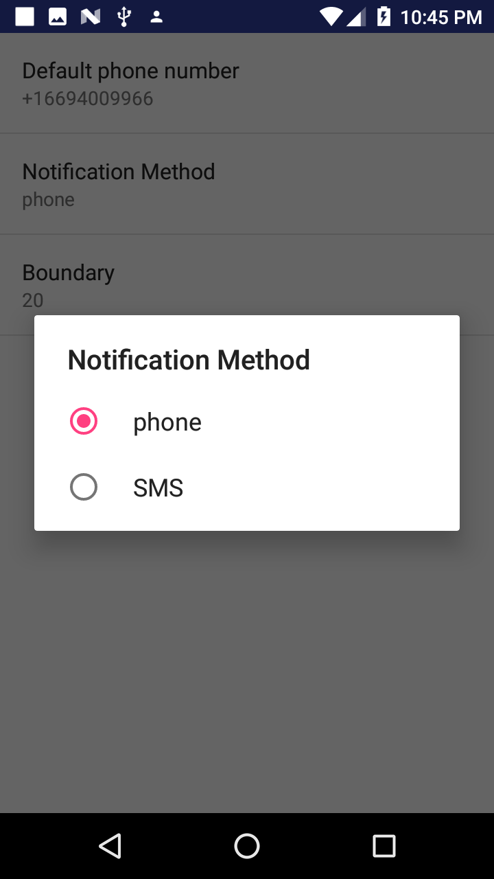

1. As soon as a fall is detected, it will immediately automatically call the person whose mobile number is set as the emergency contact number as shown below.

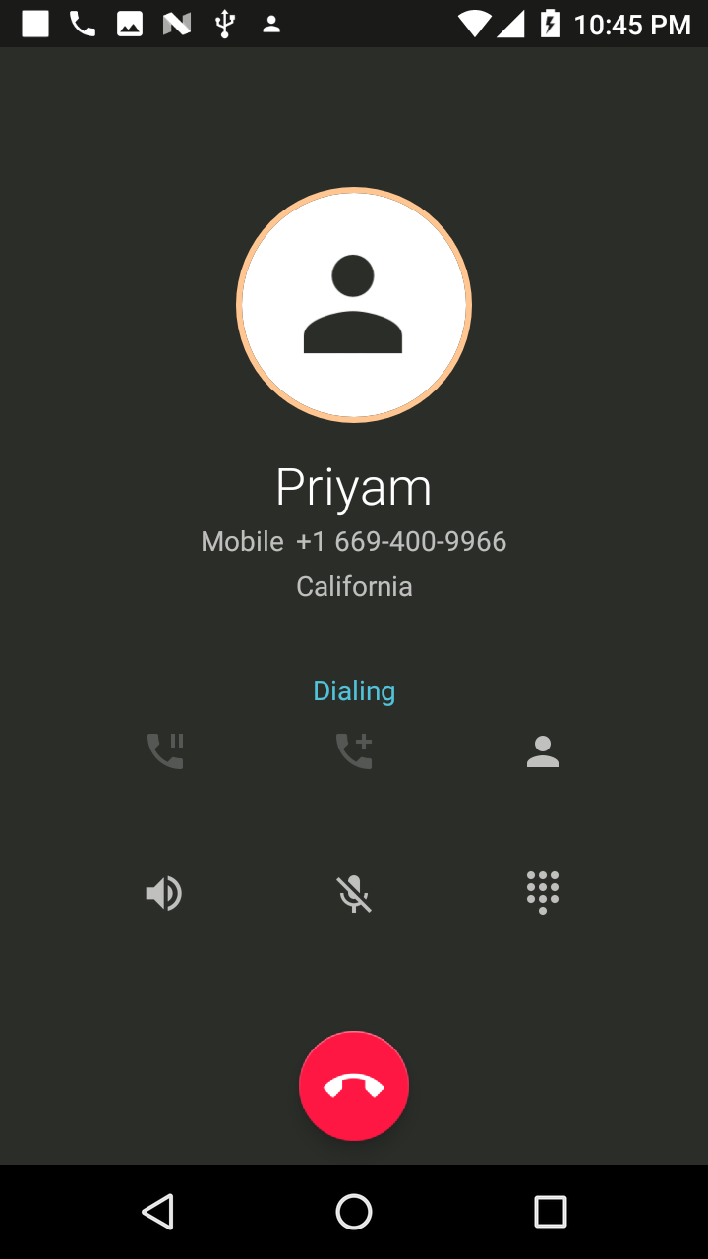

1. On clicking ‘Sleep Aid’ button from Persona app, it will take user to below screen. The use of this is, it will track movements of the user while he is sleeping, and will give an alert whenever movement is detected. This will help the user as a reminder that he needs to go back to sleep.

